**What is Energy Plus**

EnergyPlus™ is a building energy simulation program created by the U.S. Department of Energy’s Building Technologies Office. It is an open source and can be operated with the OpenStudio software along with graphical interfaces such as DesignBuilder, Revit, and SketchUp. EnergyPlus can model various aspects related to building operations such as heating, cooling, ventilation, appliance usage, and water.

**How Does Energy Plus Work?**

The EnergyPlus software is able to simulate buildings under various environments, chosen by the user. The simulation is based on fundamental heat balance principles. EnergyPlus files are ASCII text-based weather, input, and output files in hourly or even sub-hourly formats. The first input file is the building model IDF, which contains the information about the building, its systems, and its schedules. The second input file is the weather file, which contains information about temperature and solar radiation. The output variables can be selected, and include but are not limited to Air Humidity [%], Zone Temperature [C], Zone Cooling/Heating Energy [J], Zone Cooling/Heating Rate [W], Zone Lighting [J].

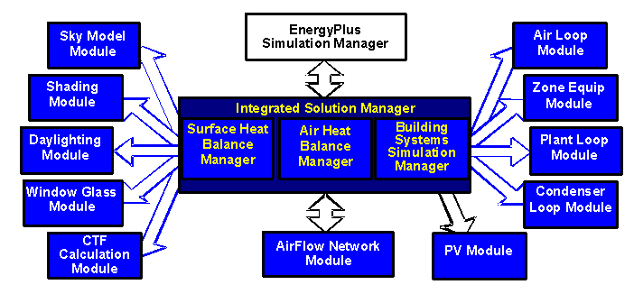

Temperature Balance Equation

The indoor temperature calculations are based on the following heat balance equation.

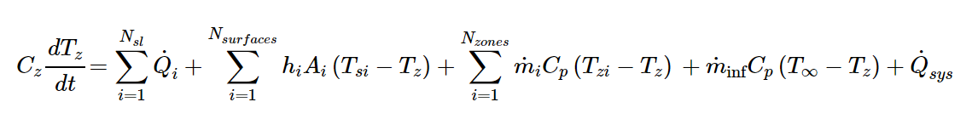

This is further simplified to

To calculate the indoor temperatures each hour, EnergyPlus utilizes a default “third order backward difference” algorithm, which uses the third order finite difference approximation to solve the zone air energy and moisture balance equations.

The U.S. Department of Energy (DOE) supports the development of commercial and residential building energy codes and standards by participating in industry review and update processes, and providing technical analyses to support both published model codes and potential changes. DOE publishes its findings in an effort to ensure transparency in its support, and to make its analysis available for public review and use.

The Pacific Northwest National Laboratory (PNNL) simulates energy savings associated with changes in energy codes and standards. This analysis is used by the U.S. Department of Energy's Building Energy Codes Program to evaluate published versions of the code, as well as in developing proposed code changes.

[Commercial prototype building models](https://www.energycodes.gov/prototype-building-models#Commercial)

**Department of Energy Prototype Building Models**

For residential buildings, PNNL uses two base prototypes to simulate the following building types: Persily et al. (2007) define a suite of over 200 homes that represent approximately 80 % of the U.S. housing stock, including detached, attached, manufactured, and apartment buildings for use in indoor air quality research. The prototypes are based on the Residential Energy Consumption Survey (RECS) and American Housing Survey (AHS) databases. The study defines the conditioned floor area (CFA) and dimensions of 3 different detached homes: 107.0 m2 (1152 ft2 ), 180.4 m2 (1942 ft2 ), and 275.5 m2 (2966 ft2 ).2

1. *Single-family* detached house
2. *Multi-family* low-rise apartment building
3. Table

   Description automatically generated

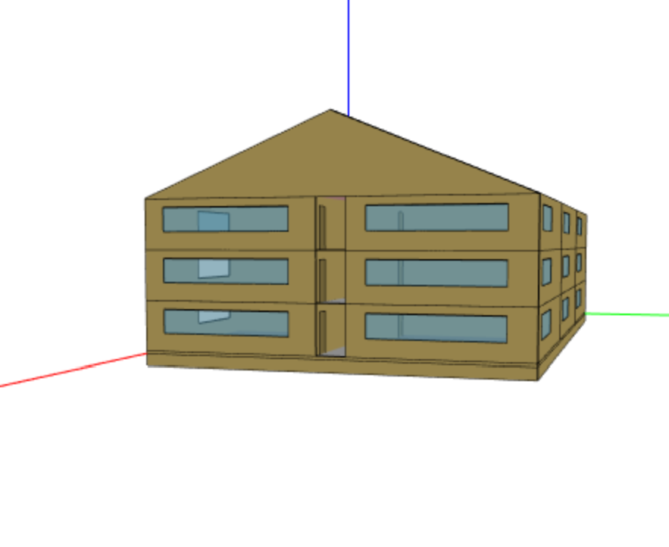 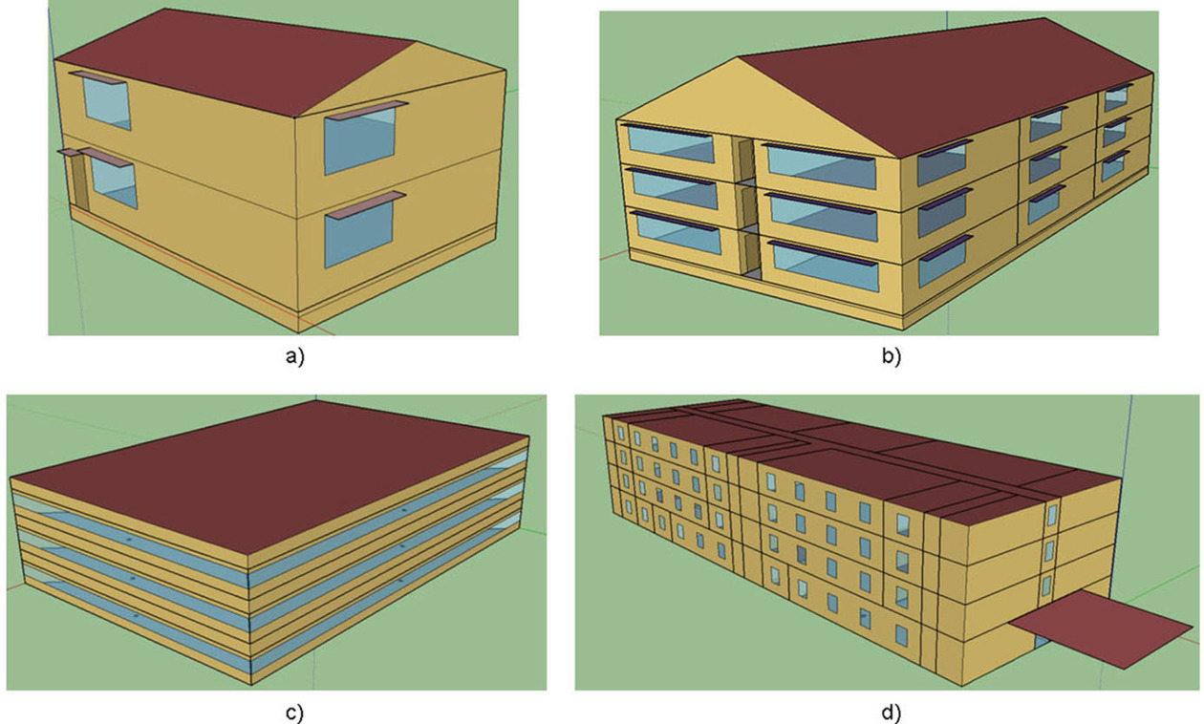

These prototypes are then modified to accommodate four different heating system types and four foundation types typically found in new residential construction. The result is an expanded set of 32 models, which is then simulated across 18 climate locations for each edition of the International Energy Conservation Code (IECC). *This combination results in a set of 3,552 residential energy models (in EnergyPlus™ Version 9.5)*.

The energy models for the 2015, 2018, and 2021 editions of the IECC are listed in Table 4. Each compressed (.zip) file includes [*EnergyPlus*](https://energyplus.net/) model input files (.idf) and corresponding output files (.htm) for each of the eight climate zones (1-8) and three moisture regimes (A=Moist, B=Dry, C=Marine) defined in the IECC.

Each file is assigned a unique name using the following naming convention:

Where,

**XX** = Prototype, either Multi-family (MF) or Single-family (SF)  
**CZ** = Climate zone designator (e.g., CZ2B for climate zone 2, moisture regime B; CZ1AT for climate zone 1, moisture regime A, Tropical, CZ3AWH for climate zone 3, moisture regime A, Warm-Humid)  
**HeatingSystemType** = One of four heating system types: Electric Resistance, Gas Furnace, Oil Furnace or Heat Pump  
**FoundationType** = One of four Foundation types: slab, crawlspace, heated basement, unheated basement  
**IECC** = International Energy Conservation Code  
**Year**= Year of published Code

Our Building Models

|  |  |  |  |  |  |  |
| --- | --- | --- | --- | --- | --- | --- |
|  | Stories | Bedrooms | Area | Heating | Foundation | Age (Pre 80/Post 80) |
| 1 | 1 | 3 | 111.6 | HP | Slab | Post |
| 2 | 1 | 3 | 111.6 | HP | UH Basement | Post |
| 3 | 1 | 3 | 111.6 | HP | Slab | Pre |
| 4 | 1 | 3 | 111.6 | HP | UH Basement | Pre |
| 3 | 1 | 3 | 176.6 | HP | Slab | Post |
| 4 | 1 | 3 | 176.6 | HP | UH Basement | Post |
| 3 | 1 | 4 | 214.0 | HP | UH Basement | Post |
| 4 | 1 | 5 | 287.3 | HP | Slab | Pre |
| 5 | 1 | 5 | 287.3 | HP | UH Basement | Pre |
| 6 | 2 | 3 | 148.8 | HP | Slab | Post |
| 7 | 2 | 3 | 148.8 | HP | UH Basement | Post |
| 8 | 2 | 4 | 202.9 | HP | Slab | Pre |
| 9 | 2 | 4 | 202.9 | HP | UH Basement | Pre |
| 10 | 2 | 4 | 202.9 | HP | Slab | Post |
| 11 | 2 | 4 | 202.9 | HP | UH Basement | Post |
| 12 | 2 | 4 | 241.0 | HP | Slab | Post |
| 13 | 2 | 4 | 241.0 | HP | UH Basement | Post |
| 14 | 2 | 5 | 297.9 | HP | Slab | Post |
| 15 | 2 | 5 | 297.9 | HP | UH Basement | Post |
| 16 | MF |  |  |  |  |  |
| 17 |  |  |  |  |  |  |
| 18 |  |  |  |  |  |  |
| 19 |  |  |  |  |  |  |

Model Outputs

Temperature Equation